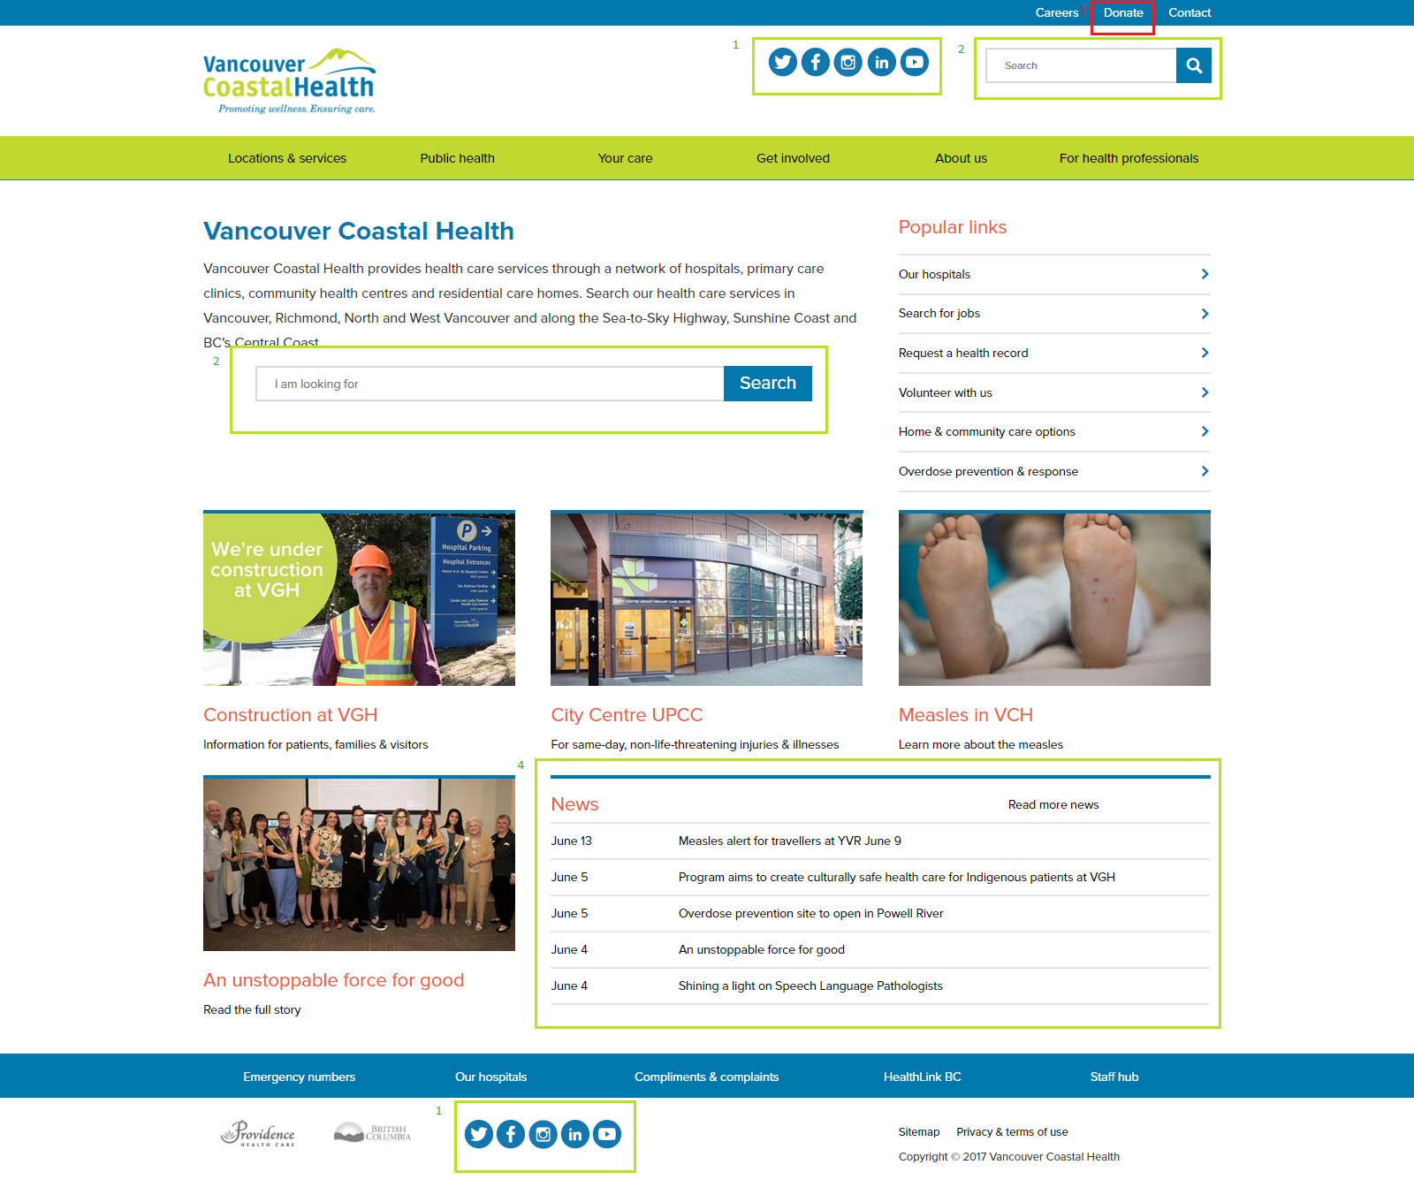

**Vancouver Coastal Health**

<http://www.vch.ca/>

**Strengths**

* Social media icons displayed prominently **1**
* Search bar is easy to find (x2) locations **2**
* Navigation is organized logically

**Weaknesses**

* Hard to find addictions services

**Opportunities**

* Lack of **call to actions**
* **“**Donate” link is tiny and hard to find **3**

**Threats**

* Updatable news feed **4**

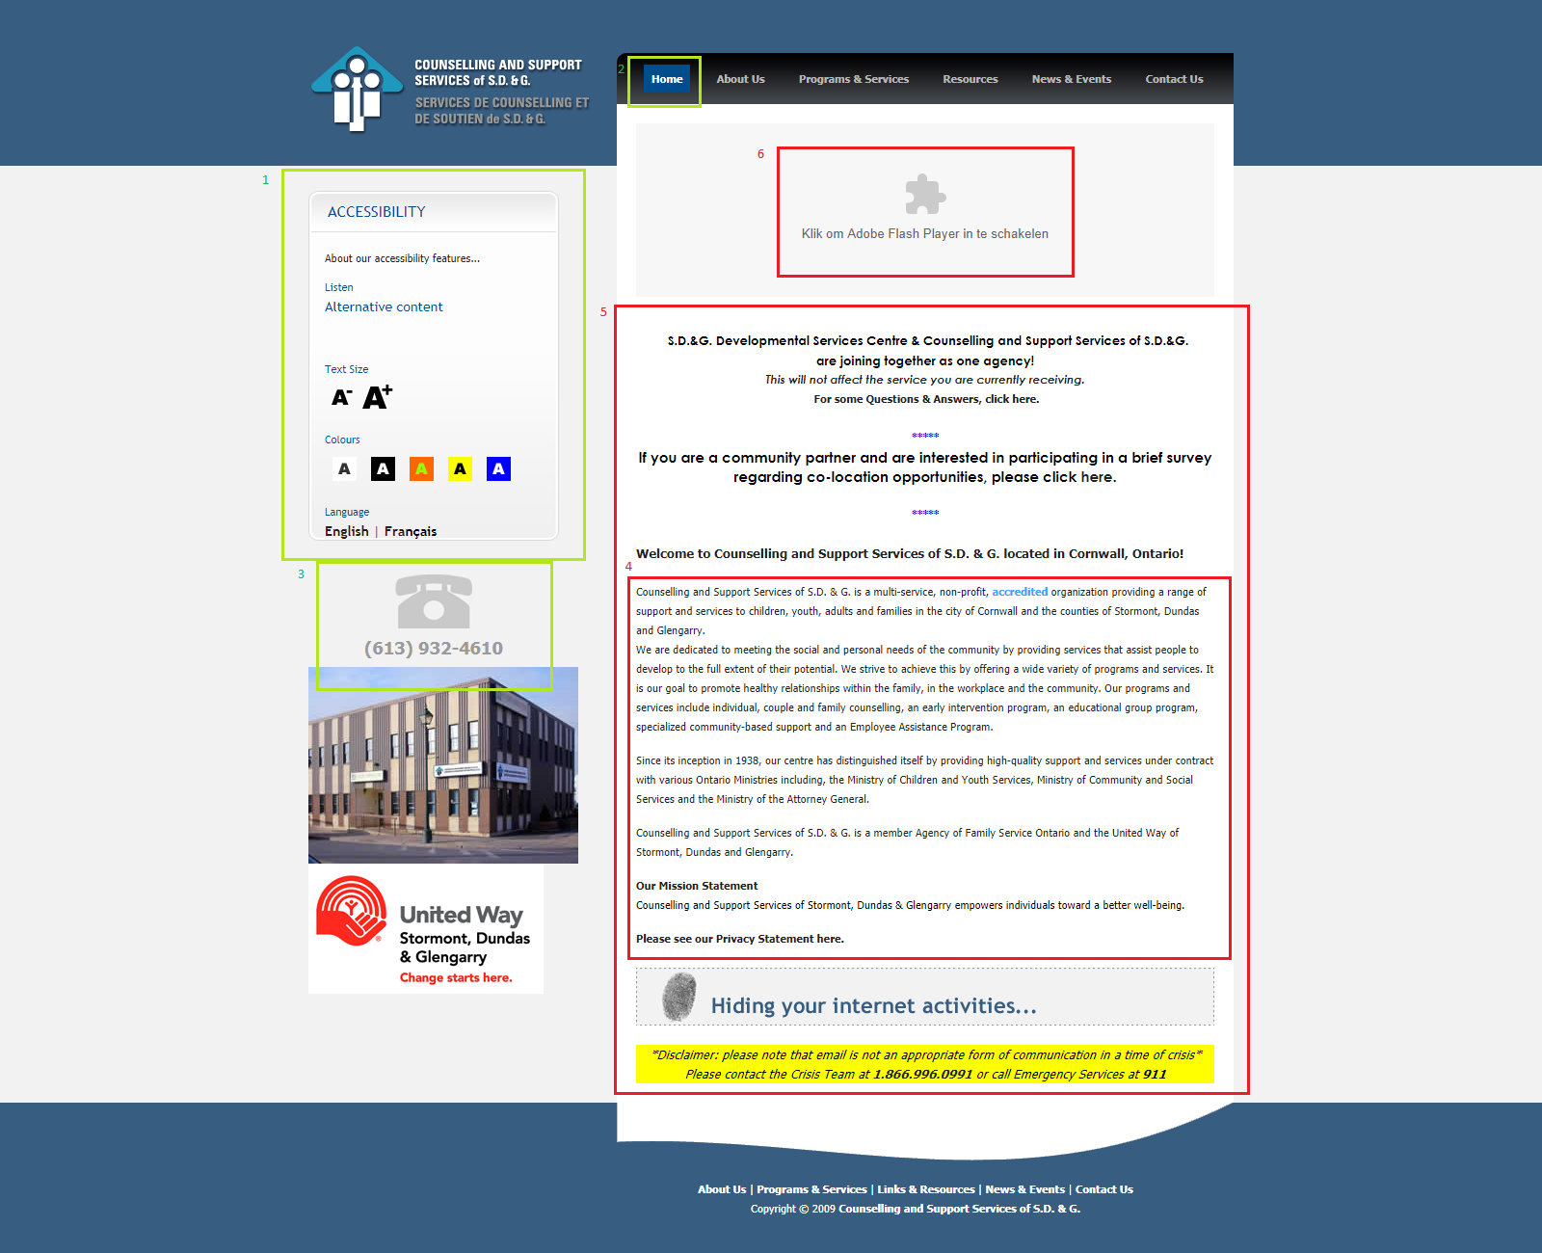

**Counselling and Support Services of S. D & G**

<http://css-sdg.ca/>

**Strengths**

* Incorporates an **accessibility toolbar** **1**
* clear “You are here” moments defined by a highlighted nav link **2**
* Phone number is easy to find **3**

**Weaknesses**

* Out of date design
* Font is small and compact **4**
* Visual hierarchy is a little confusing, I’m not sure what info is most important **5**
* Site uses Adobe Flash **6**

**Opportunities**

* Site lacks social media
* very **Static** page, no news or events posted on the homepage or even under “News & Events”

**Threats**

* **Accessibility** toolbar is clearly defined and easy to locate on all pages **1**

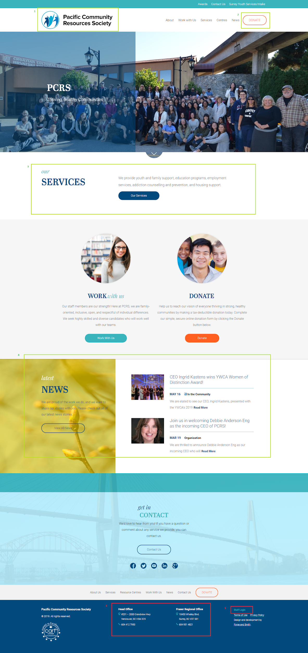

**Pacific Community Resources Society**

<https://pcrs.ca/>

**Strengths**

* Good use of tabs (on pages other than homepage)
* Logo is easy to find **1**
* Good use of white or “empty” space
* ”Donate” button is easy to find **2**
* ”Our Services” is the first thing you see on the first scroll **3**
* Text is minimal
* Font is clear and easy to read
* They have a new feed! **4**

**Weaknesses**

* Can’t find any

**Opportunities**

* ”Staff login” could be in top utility bar as well as the footer **5**
* Office addresses could link to Google Maps **6**

**Threats**

* Simple design that is well laid out and clear

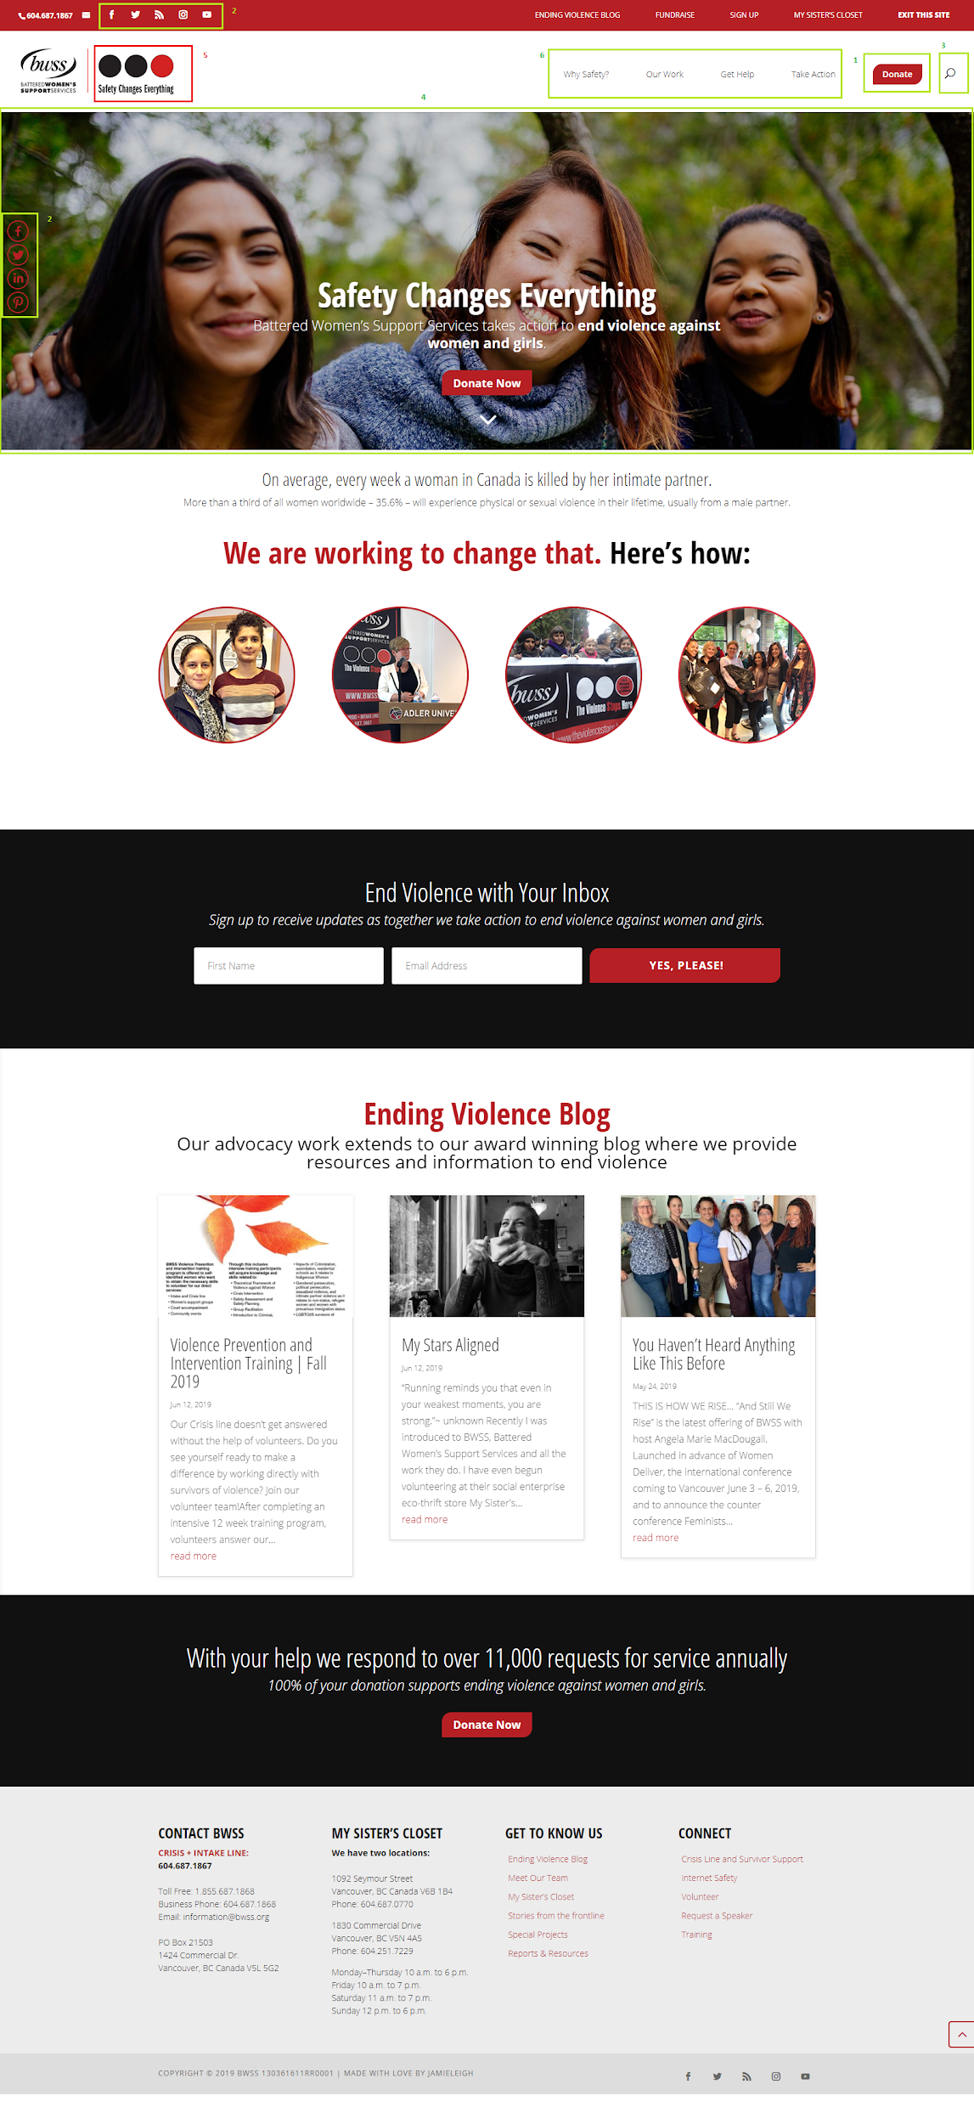

**Battered Women’s Support Services**

<https://www.bwss.org/>

**Strengths**

* Clear ”Donate”call to actions (x2) on homepage **1**
* Sticky nav bar
* Social media icons are present (x2) on every page **2**
* search bar is easy to find **3**
* color pallet is simple and clean
* page titles are clearly defined using hero images **4**
* good “you are here” moments once you are on a page

**Weaknesses**

* Hover over image links have a weird overlay
* Home logo has three circles next to it that are clickable, but don’t do a whole lot **5**

**Opportunities**

* ”There’s no “home” link in the nav bar

**Threats**

* good photo to text ratio, information is easy to scan
* navigation is simple and self-evident **6**

**Common Strengths**

* Use of **social media icons**
* Prominent **search bars**
* **Clear navigation** and `you are here` indicators
* **Simple colour scheme**
* Good use of **call to actions**
* Prominent **`Donate´ buttons**
* **Minimal Text**
* Use of a **New Feed**

**Common Weaknesses**

* Confusing navigation

|  |  |  |  |  |
| --- | --- | --- | --- | --- |
|  | <http://www.vch.ca/> | <http://css-sdg.ca/> | <https://pcrs.ca/> | <https://www.bwss.org/> |
| **Strengths** | -Social media icons displayed prominently  -Search bar is easy to find (x2)  - navigation is organized logically | -Incorporates an accessibility toolbar  -clear “You are here” moments defined by a highlighted current link in nav  -phone number easy to find | -good use of tabs  -logo is easy to find  - color scene is simple  -good use of white or “empty” space  -”Donate” button is easy to find  -”Our Services” is the first thing you see on the first scroll  - text is minimal  -font is clear and easy to read  -they have a new feed! | -clear ”Donate”call to actions (x2) on homepage  -sticky nav bar  -social media icons are present (x2) on every page  -search bar is easy to find  -color pallet is simple and clean  -page titles are clearly defined using hero images  -good “you are here” moments |
| **Weaknesses** | -hard to find services | -Out of date design  - font is small and compressed making it hard to read  -Visual hierarchy is a little confusing, I’m not sure what info is most important  -site uses flash :\ |  | -hover over image links have this weird “+” inside of an “O” icon that usually means “add this to somethime”, “new” or “expand” confusing  -Home logo has three circles next to it that are clickable, but serve no function |
| **Opportunities** | - lack of call to actions  -Donate is a small link that blends in with other utilities | -lack of social media  -very **static** page, no news or events posted on the homepage or even under “News & Events” | -”Staff login” could be in top utility bar as well as the footer  - Office addresses could link to Google Maps | -There’s no “home” link in the nav bar |
| **Threats** | -updatable news feed | -Accessibility is clearly defined and easy to locate on all pages | -simple design that is well laid out and clear | -good photo to text ratio, information is easy to scan  -navigation is simple and self-evident |